**Step 1: Set Up a Connection to Your Amazon RDS Instance**

1. **Open DBeaver**.
2. In the **Database Navigator** panel on the left, click on **New Database Connection** (or go to **Database** > **New Database Connection** in the top menu).
3. Select the **MySQL** (or the database engine you're using) from the list of databases. Click **Next**.
4. In the **Connection Settings** window:
   * **Host**: The **endpoint** of your RDS instance (found in the AWS console under your RDS instance details).
   * **Port**: Default MySQL port is 3306 (unless you’ve configured something different).
   * **Database**: Leave it blank for now; you can select an existing database or create a new one.
   * **User**: The RDS master username you created when setting up the instance.
   * **Password**: The password for the RDS user.
5. Test the connection by clicking **Test Connection**. If successful, click **Finish**.

**Step 2: Create a New Database in RDS**

1. After connecting to your RDS instance, right-click on your **Connection** in the **Database Navigator** and select **New SQL Script**.

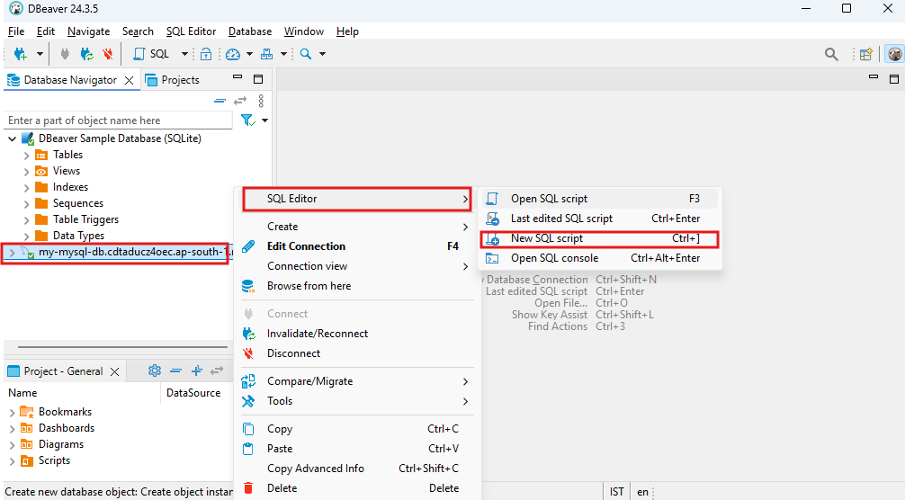

1. In the **SQL Editor** window that appears, use the following command to create a new database:

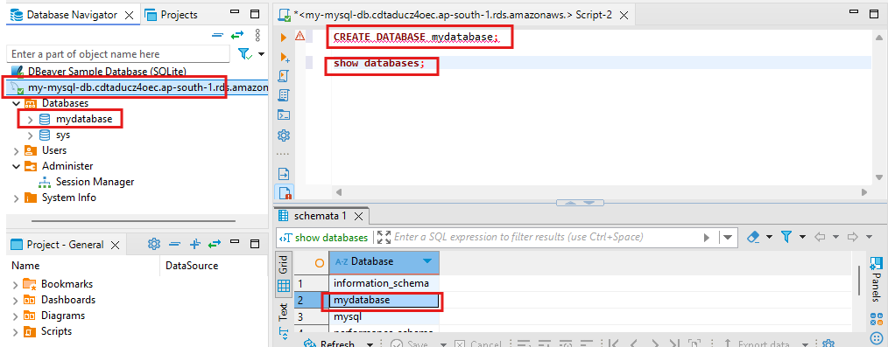

1. Click the **Execute SQL Script** button (or press Ctrl + Enter on your keyboard) to run the SQL query and create the database.
2. Once the database is created, refresh the **Database Navigator** by right-clicking the connection and selecting **Refresh**. Your new database should now appear in the list.

**Step 3: Create a Table in the New Database**

1. After creating your database, select your newly created database (mydatabase) from the **Database Navigator**.
2. Right-click the **Tables** folder under the new database and select **Create New Table**.
3. In the **Create Table** dialog, define your table structure. For example, to create an **employees** table, use the following SQL:
4. After defining the table structure, click **OK** to create the table.